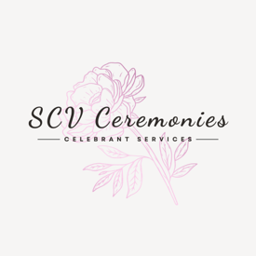

Suzanne Vernon (SCV Ceremonies) is committed to ensuring the security and protection of the personal information that it processes. I am also committed to developing a data protection regime that is effective, fit for purpose and demonstrates an understanding of the new General Data Protection Regulations (GDPR) 2018. You can find out more about the new GDPR on the website of the information Commissioner Office www.ico.org.uk

If after reading this statement you have any questions, please contact me. I can be emailed
suzannevcelebrant@gmail.com Always use a secure internet server.

I ask you to read this statement carefully because it contains important information about:

• The personal information I collect about you as a customer/potential customer.
• What I do with your information and who your information might be shared with.

Examples of Personal Data.
• Your name(s).
• Address(es).
• Telephone number(s).
• Email address(es).
• Your age.
• Your sexuality
• Your race.
• Identifiable Photographs.
• Details of your ceremony and chosen venue.

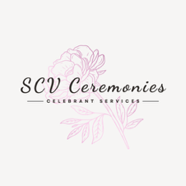

What information do I collect?

Suzanne Vernon (SCV Ceremonies) will treat your data with respect and it will not be actively shared with third parties unless consent is given by the couple.
I may collect the following personal information that you provide me with:
• Your name(s).
• Address(es).
• Telephone number(s).
• Email address(es).
• Your age.
• Your sexuality
• Your race/culture.
• Identifiable Photographs.
• Details of your ceremony and chosen venue.

Please remember that whilst I may not directly ask you for some of these details you may indirectly disclose them to me, for example

• If you request a same sex ceremony, this will indicate your sexuality.
• If you request a certain theme, this may indicate your race/culture.

You may choose to make such requests in person rather than online if you prefer.

You can withdraw your consent to use your personal data.

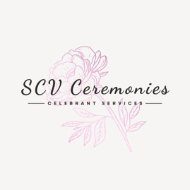

Suzanne Vernon (SCV Ceremonies) operates an “opt in” approach for data usage and storage. By submitting your details or utilising the website and associated links or forms, you are opting into data collection and usage. (This is known as ‘implied consent.’) On appointment of my services,
you will also be asked to sign an opt in data collection form. You may at any time opt out by making a formal request to me via my email address. Please ensure you receive written confirmation that your “opt out” request has been acknowledged. In this circumstance I will no longer use specific information you have provided from this point on. However, you need to be informed that any published and public materials that already includes your information or photos cannot be recalled.

How I store and destroy the data that I collect.
All personal and sensitive information divulged to me will remain confidential.
Paper files will be kept locked at my home address and destroyed after use via shredding.
Contact forms, questionnaires and wedding scripts will be held electronically for one month post event to allow you to access them; documents can be destroyed earlier than one month on written request of the couple. I will only retain emails from you that relate to the current enquiry, they will be deleted when they are no longer relevant. Electronic files on my devices
will be firewalled and password protected.

Please note that email or message correspondence to Suzanne Vernon
(SCV Ceremonies) does not offer any additional encryption other than what is provided as standard from both the email servers and web site.
I Suzanne Vernon (SCV Ceremonies) am not affiliated with either of these companies other than as a user of their services and cannot be held liable for any breaches to GDPR regulations made on their part.

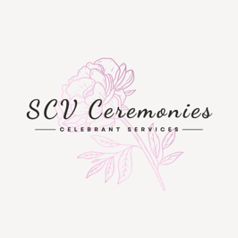

Locations your data may be held by myself consist of:
Suzanne Vernon (SCV Ceremonies)

Whilst I will make all reasonable efforts to secure your personal data, in using my sites you acknowledge that the use of the internet is not entirely secure and for this reason I cannot guarantee the security or integrity of any personal data that are transferred from you or to you via the internet.
Personal information provided by third parties.

Personal Information provided to third parties.
With your permission I may contact a venue/supplier on your behalf. I will always gain your consent first. (You should only disclose details about your suppliers to me that are in the
public domain)

Examples of third-party involvement:
• I may contact your other suppliers such as the photographer or musician, to ensure they are familiar with the order of the ceremony.
• I may contact your chosen ceremony venue to check on any restrictions they may impose.
•Elements of your script may be anonymised and shared for training and development purposes or to seek professional advice.

• If you submit feedback, your personal data may be used in evaluation and monitoring activities post event by Suzanne Vernon (SCV Ceremonies), to ensure continuing high standards of practice.
• I share my invoices, spreadsheets and bank statements with my accountant to comply with tax return regulations, financial records are held for 5 years.
• I would be compelled to share information with law enforcement agencies in connection with any investigation to help prevent unlawful activity or for fiscal agencies such as HMRC.



Additional Data Collected.

All websites including this one collect and store any information you enter on the website or provide me in any other way. In addition, the website logs your Internet protocol (IP) address used to connect your computer to the Internet; this may include but is not limited to login, e-mail address, password, computer and connection information. The site may use software
tools to measure and collect session information, including page response times, length of visits to certain pages, page interaction information, and methods used to browse away from the page.
The site may also collect personally identifiable information, including names, email addresses, communications, comments, feedback, product reviews, and recommendations, should you choose to provide them.

Cookies.
Cookies are small pieces of data stored on a site visitor's browser; they are primarily used to keep track of their movements and actions on a site.

In accordance with the GDPR, I must inform you that my sites use cookies.

Cookies are implemented on every internet site:

Cookie name - Life span:
svSession - Permanent
hs - Session
incap_ses_${Proxy-ID}_${Site-ID} - Session
incap_visid_${Proxy-ID}_${Site-ID} - Session
nlbi_{ID} - Persistent cookie
XSRF-TOKEN - Persistent cookie
smSession - Two weeks

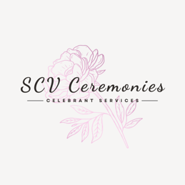

If you access my site via another web page, an advert link or a social media page, please be aware that these sites also operate their own privacy policies, cookies and tracking. Examples of other web pages or social media pages you may access are:
• Facebook.
• Instagram.

Please check these sites for their privacy policies and cookie usage, which can be found online.

Internet sites are also monitored for analytical purposes by search engines such as Bing and Google, please check the search engines own policies for their cookie usage and data protection policies. You can set your own device to manage cookies or clear cookies by following the user instruction for your device.

How do websites collect information?
When you interact with or view the website, click on links or utilise the contact form as part of the process, the site collects information about your activity and the associated personal information you provide such as your name, address and email address.

Why is this information collected?

This information is collected for the following purposes:
1. To provide and operate my services.
2. To design and deliver your bespoke ceremony.
3. To provide my customers/visitors/users assistance and technical support.
4. To be able to contact my customers/visitors/users with general or
personalized service- related notices and promotional messages, if
they request such contact.

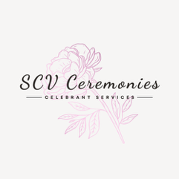

Why is this information collected? (Continued)

5. To create aggregated statistical data and other aggregated and/or inferred
Non-personal Information, which I may use to provide and improve
my respective services.
6. To comply with any applicable laws and regulations.

How do sites store, use, share and disclose site visitors' personal information?

All web pages are hosted on platforms, which allow me to advertise my services to you. Your data may be stored through the host platforms data storage, databases and the general applications. It is best practice that they store your data securely. Further detail on host platforms can be found on the host sites privacy statements.

How is communication initiated?
If I need to contact you, it will be through the details you actively provide to me. For example, via email, telephone, text messages, and postal mail. Do Not submit any forms of contact that you do not wish to be utilised.

Access to your Data.
You can request a copy of the information which I hold about you, this is known as a ‘subject access request.’ You may nominate others to access your data via a sharing agreement in writing which must be clearly signed where practical by both members of the Couple. As a minimum the sharing agreement must be signed by at least one member of the Couple.

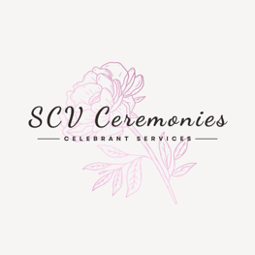

Right to correct any mistakes or changes about your information.
You can request via email that I correct any mistakes or changes about your information. If you would like to do this, please let me know the information that has changed or is incorrect and what it should be replaced with.

Privacy Statement Updates.
I reserve the right to modify this privacy statement at any time, so please review it frequently. Changes and clarifications will take effect immediately upon their posting on the website. If I make material changes to this statement, I will notify you here of the date that it has been updated. If any changes are made to the privacy statement, your right to “opt out” or “withdraw consent” for data use remains the same.

Questions.
If you have any queries or concerns about the privacy statement or any details I hold about you, please contact me via email: suzannevcelebrant@gmail.com Always ensure you use a secure server

